FINANCIAL YEAR REPORT 2020-2021

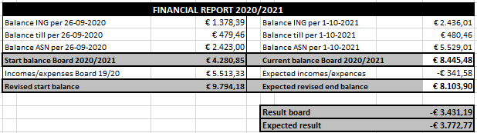

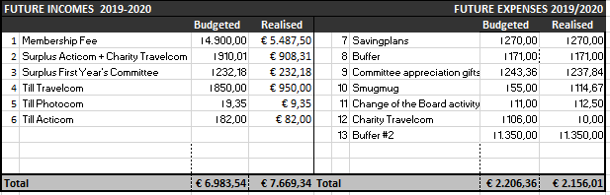

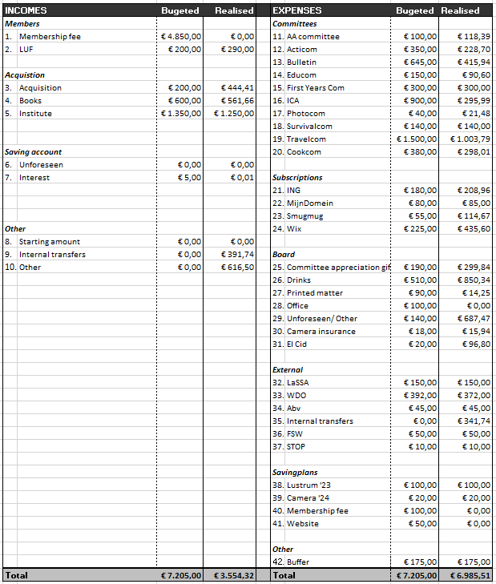
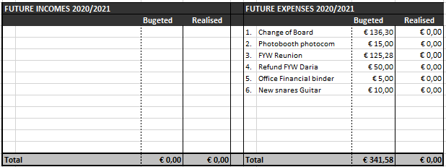

Explanation Financial Year Report
INCOMES
Members
- Membership Fee: This board year did not use any contribution as income this year, so that from Board 29 onwards, the contribution being paid by the members is also being spend that same year. This also explains the imbalance of this financial report 2020/2021.
- LUF: This contribution is paid once a year. This year the contribution was higher than budgeted.
ACQUISITION
- Acquisition: This amount consists of an annual contribution from Drukbedrijf Joorit, the profit of the Jewellery Line of the AA Com, and the profit of the post cards of Acticom.
- Books: We received the money from the booksale in April.
- Institute: This concerns the the contribution of the institute to Itiwana, a part of this amount is reserved for the annual study trip. This year, the amount was lower than budgeted.
SAVING ACCOUNT
- Unforeseen: There were no unforeseen incomes this year.
- Interest: This year we received €0,01 interest.
OTHER
- Starting amount: This is the amount that has been saved on the ING account for the last couple of years. This amount has been made fully available to make up for the shortage of acquisitions so that it will not be taken from the committees budgets. None of this has been used yet.
- Internal transfers: Items intended for income that is quickly spent again. This year, that included the contribution for ABV (because it was paid twice), and the refunds of the FYW of the people who ended up not able to come, but still paid.
- Other: The members of Board 28 received 600€ personally (from which half has gone to Itiwana as a gift from Board 28) for surveillance of the study rooms at the University, which was transferred to the bank account of Itiwana.

EXPENSES
COMMITTEES
- AA Committee: The AA- committee went 18,39€ over budget, but made 179,41€ as profit with the Jewellery Line.
- Acticom: Acticom has spent most of its money, the only activity left is Change of Board Party, which will be paid after the Change of Boards.
- Bulletin: Bulletin Issues 1,2,3 have been paid. Edition 4 will be online.
- Educom: The Educom did not spend all of their budget this year, thus there is money left.
- First-years Committee: The FYC spend their entire budget this year.
- ICA: Issue 1 was online (and thus free), Issue 2 was offline and has been paid. Because we only ordered copies for the members who wanted to receive one, there is a lot of money left.
- Photocom: Photocom has still one (possible) activity left, the Photoboot at the Change of Boards Party, which will be paid after the Change of Boards.
- Survivalcom: The Survivalcom has spent their entire budget this year, most of which went to the FYW.
- Travelcom: The Study Trip ended up being less expensive than was budgeted, which resulted in the Travelcom not spending their entire budget this year (and the members also receiving part of their money back).
- Cookcom: The pilot year of the Cookcom was successful, most of their budget has been spent, though the budget left enough playing room which resulted in having money left.

SUBSCRIPTIONS
- ING: The costs for payment done online. They ended up being more than was budgeted, due to the fact that more ‘transaction lists’ were being send.
- Mijndomein: The membership fee to continue to use the emails of Itiwana.
- Smugmug: The website where the photos of Itiwana activities are saved and members can see them. This year it has been paid twice, since last year was forgotten (due to an old board member still paying it with her creditcard. This will be solved next Board year).
- Wix: The membership fee for the Itiwana Website. This is a once-in-two-year subscription. It was not budgeted at the beginning of this year, so it will be (re)introduced in the budget/savingsplan from now on. There was no saving plan for it before, so we paid the full membership of €435,60.

BOARD
- Committee appreciation gifts: The gifts for this year’s committee appreciation gifts are paid. Due to having more committee members, this amount turned out to be slightly higher than budgeted.
- Drinks: This money is meant to be spent on the constitution drinks of Itiwana, the lofts and the drinks. However, this year, we also used it for the Volleybal Tournaments and the Itiwana Day, which caused spending more than budgeted.
- Printed matter: This concerns the printings of posters, committee information booklets and cobo- and Christmas cards.
- Office: There have not been made any expenses for the office this year due to being closed for the majority of the Academic Year.
- Unforeseen/Other: There are some unforeseen costs that had to be paid. This mainly concerns costs associated with the merchandise of September 2020, sending labels, costs for the Logo Competition and PC Leden (of which the subscription was not yet cancelled).
- Camera: The camera insurance for this year has been paid.
- El Cid: This year we shared a stand with Emile for the Information Market at the El Cid.

EXTERNAL
- LaSSA: This concerns the annual contribution to the national study association anthropology students. This contribution has been paid.
- WDO: WDO receives an amount from Itiwana according to the distribution key of 9% of the contribution. This amount has been transferred (- the bill of 20€ the WDO had to pay for the Symposium gifts).
- ABv: By transferring the contribution from the Abv, this amount was paid for the contribution of 2019.
- Internal transfers: Items for expenses that will be paid back soon. This includes the money for the double contribution payment of the ABv and the refunds of the FYW.
- FSW: This money is intended for activities organized in collaboration with the study associations of the FSW.
- 37: StOP: This concerns the annual contribution to the Studenten Overleg Platform and has been paid.

SAVINGPLANS
- Lustrum ’23: This amount has been transferred to the Savings Account.
- Camera ’24: Idem.
- Membership fee: This has not been transferred, since this saving plan was not necessary anymore due to left-over money from last year and this year which we could use to improve the contribution system.
- Website: This has not been transferred because the Website has been paid this year and a new saving plan has been set up.
OTHER
- Buffer: This amount has been transferred to the Savings Account.

FUTURE INCOMES 2020/2021
As for now, no future incomes are expected.
FUTURE EXPENSES 2020/2021.
- Change of Boards: The last activity of the Acticom, change of board party, has not yet happened and still has to be paid.
- Photobooth Photocom: The last activity of the Photocom will probably be a Photoboot at the Change of Board Party, so this amount still has to be paid.
- FYW Reunion: Due to leftover money from the FYW, a reunion will be organized in the first semester.
- Refund FYW Daria: One of the members who could not come to the FYW (but still paid), still has to receive their refund.
- Office Financial Binder: A new binder has to be purchased for the financial documents in the Hok.
- New snares Guitar: During the FYW, the guitar broke down, so new snares have to be purchased for it.

COMMITTEES
AA- COMMITTEE
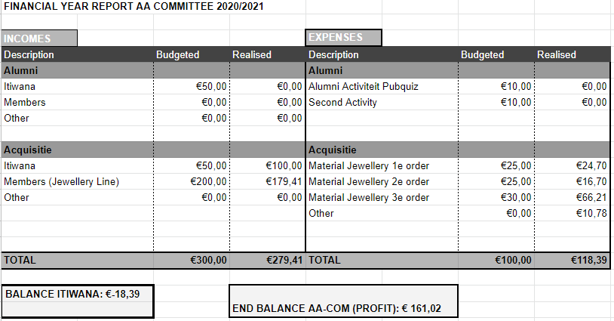

ACTIVITIES COMMITTEE
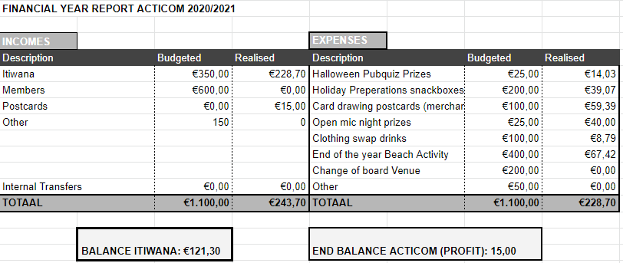
BULLETIN
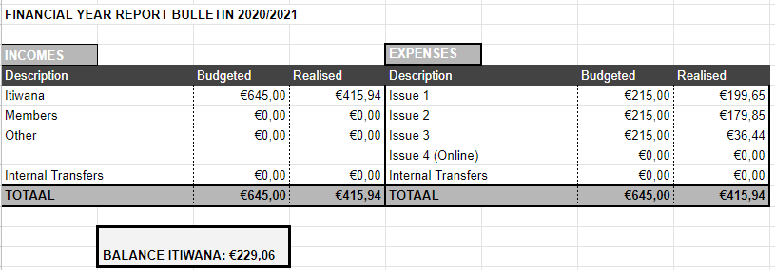

EDUCATION COMMITTEE
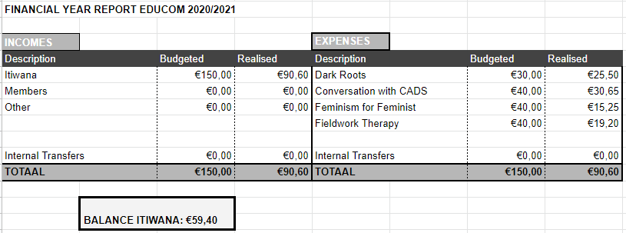

FIRST YEARS COMMITTEE
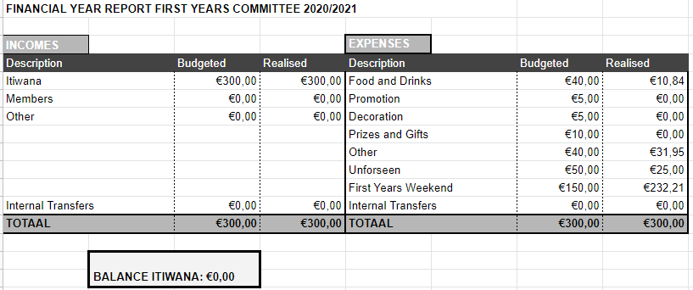

ICA
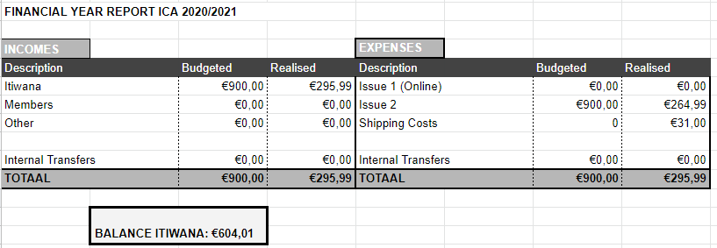

PHOTOCOM
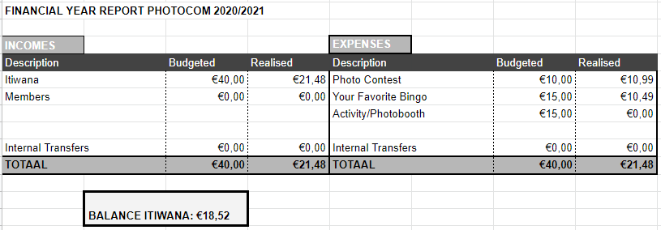

SURVIVALCOM
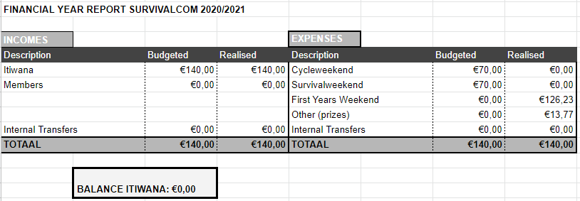

TRAVELCOM
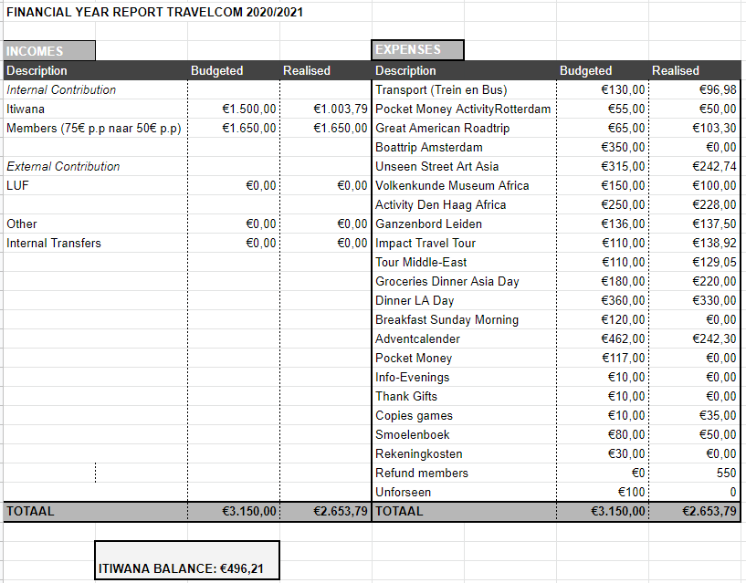

COOKCOM
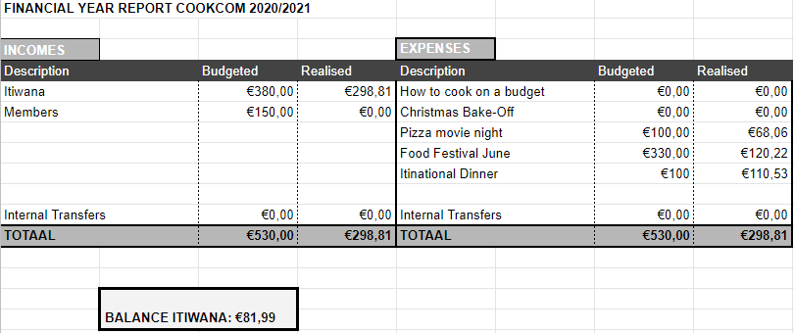

FISRT YEARS WEEKEND
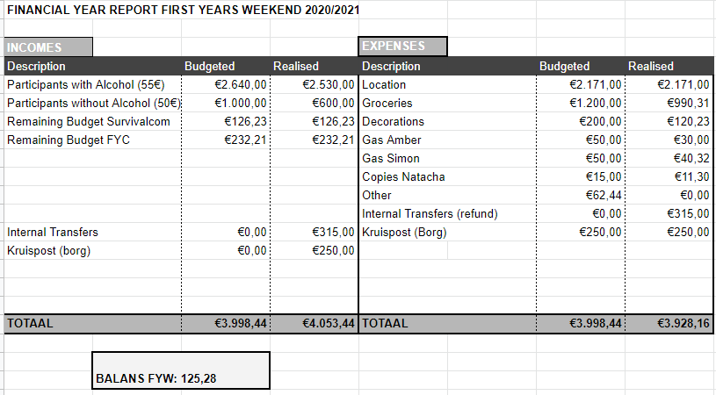

ADVICE BUDGET
